VCE Systems Engineering

**System Description:** Written Description Notes

Structure

1. Identify the important parts to the system.
2. List the energy, material and information requirements of the system.
3. Describe the desired result from the system.
4. Detail the important steps in the operation and function of the system including the energy, force and motion transformations at each step.

Example: Electric Toaster

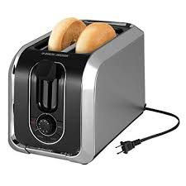

The electric toaster has two slots to place bread into, a spring lever and carriage to lower and raise bread and heating elements either side of the bread. It also has a mains flex for connecting to a power point to power it, along with a button or dial to stop toasting and to control the amount of toasting of the bread.

The electric toaster requires sliced bread or food stuffs the thickness of sliced bread i.e. crumpets, pancakes, pop tarts, etc. It requires mains power of 240 volts to operate with an appropriate toast setting selected by operator.

The desired result from the system is nicely toasted slices of bread called toast, that then usually has any range of condiments applied to them, like butter and honey.

The toaster functions by placing two pieces of bread into the slots at the top, the toast setting is selected on a dial, then the spring lever is pushed down to lower the bread into the toaster to align them with the heating elements. This creates elastic potential energy with the compressed spring. From this point, mains power is supplied to the heating elements which converts electrical energy into heat energy, with the bread heating and toasting over a number of minutes. Once the target time is reached the spring lever carriage is released. The potential energy is converted to kinetic energy to push the now toasted bread out the top slots for collection by the operator.